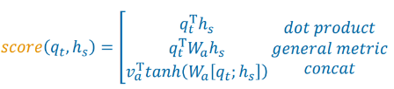
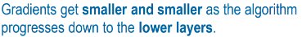
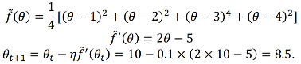
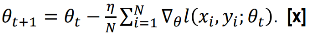
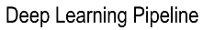
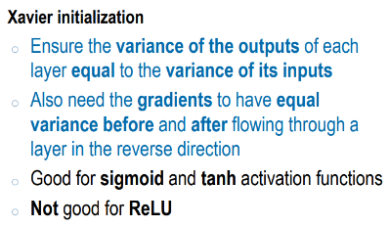
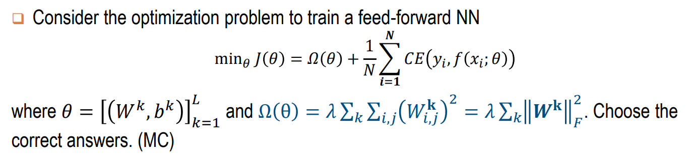
Early Stopping (when validation loss no improves prevent add noise after understand general data), Adding more data, Weight regularization (penalise large weight prevent highly rely on specific param), Using Dropout
Alignment Score
The valid test is a replicate of testing set for evaluating the model best performance on the valid set to decide if it is a good model that can work well on testing set
Update rule of stochastic gradient descent
Update rule of gradient descent
[(Input + 2*padding – kernel)/ stride] +1
Encourage simple model, combat overfitting
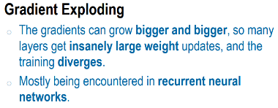
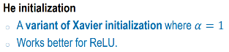
We use powerful deep nets to learn from simple data. The training accuracy is high and the valid accuracy is low. The model performs very well on the training set, but cannot generalise to perform well on a separate testing set
Overfitting
Underfitting
Minimizing more fit to training set, lead to overfitting
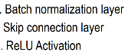
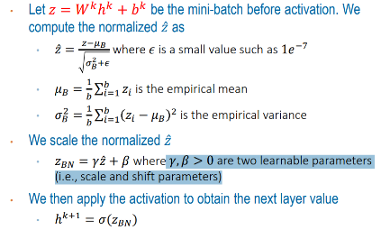
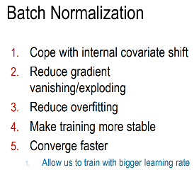
We use a simple model family to characterize and learn from more complex data. Both training and valid accuracies are low. The model is too simple to characterise a training set
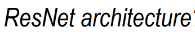
Receptive field of neurons higher layers = larger, value of neuron relevant to receptive field
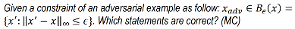
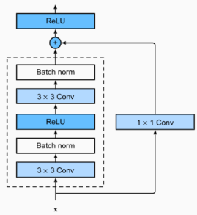
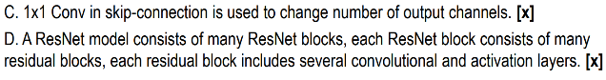
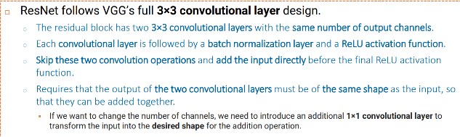
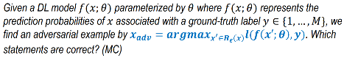
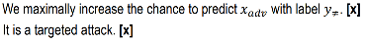
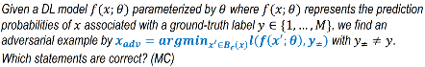
Address using gating mechanism: add linear component from previous layer: LSTM/GRU
First order Markov Assumption
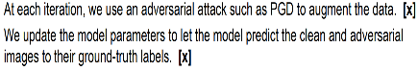
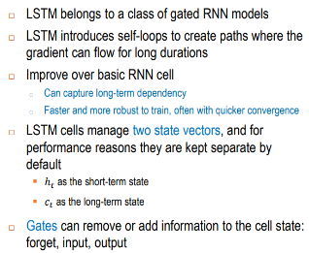
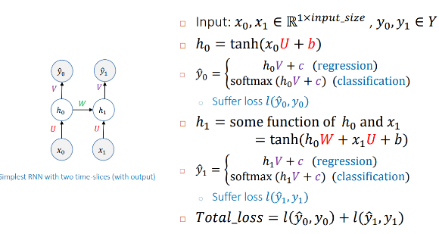
The final loss consists the losses over clean and adversarial examples
LSTM
GRU

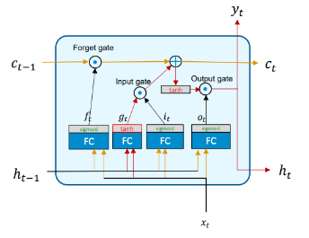
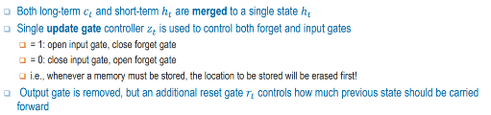
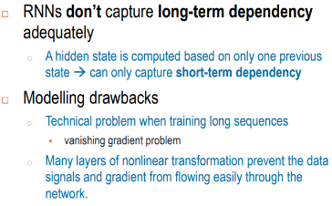
Skip-gram Bad
Skip-gram Negative Sampling
The SoftMax output layer is computationally expensive. The values of prediction probabilities are small and hard to distinguish among classes. Skip-gram depends on the context window size.
apply sigmoid activation function at the output layer. Given a pair target word and context word, we need to randomly sample some negative words and minimize the probabilities to predict the pairs of target word and negative words as a positive pair. We need to maximize the probability to predict the pair of target word and context word as a positive pair.
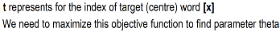
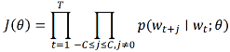
Input is one-hot vector 15
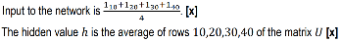
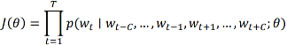
Encoder-Decoder
Max log-likelihood obj f
Encoder tries to encode an input sequence to a context vector. Decoder tries to read from context vector to generate an output sequence. Context vector last state of encoder and summarizes an input sequence. Both is RNN
T = Total no of word
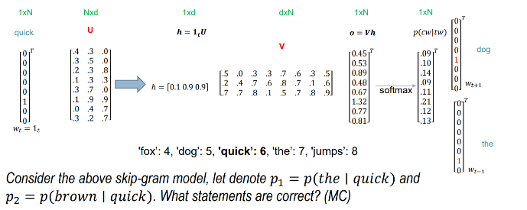
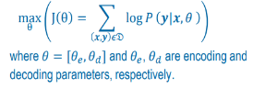
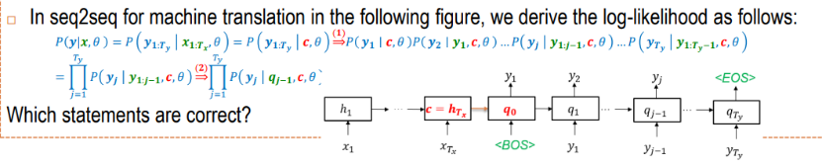
Global/Local Attention
In the global attention, the time varied context is computed based on all encoder hidden states, the time varied context is a linear combination of all encoder hidden states. If local then add “in a selective window”
Fixed-length context is possibly less powerful to capture long input sequences, while timely
varied context can provide dynamic and timely adapted context for input sequences. Timely varied context can focus on some input items or words that are more important to generate specific output items or words, while fixed-length context cannot.
Last encoder state use as context vector cuz it contains all input token after process full source sequence, acts as a summary
Vocabulary size is 8 and embedding size is 3. 𝑝1 = 0.12, 𝑝2 = 0.11. If CBOW then hidden layer adds all 1, find average
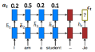
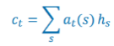
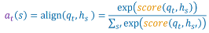
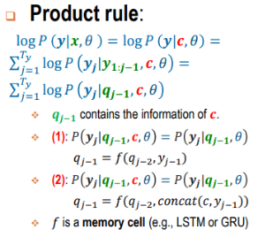
Alignment Weight
Swin Transformers Window Self-Attention: divide all token embeddings into many local windows and then apply the Self-Attention to each local windows independently. output shape of Window Self-Attention is the same as the input shape.
(ViT): can naturally capture the global information of images. can find the long-term dependencies among image patches. need massive datasets to train ViTs.
(ViT): a token or visual word is a patch of an image. apply a linear projection to the flattened patches to transform them to token embeddings. Inject the class token to the token embeddings of the patches and learn the class token fixed during training. On top of the class token at the final layer, we build up the MLP head to make predictions.
BOS: beginning of sequence, initialize the decoder. EOS: End of sequence, tell the decoder when to stop generating output
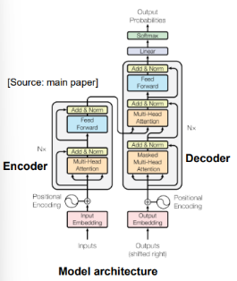
Use attention to overcome, compute time vary Ct at each decoding step using formula above, attention weights decide how much decoder should focus on encoder hidden state, multiple with encoder hidden state lets decoder to focus on most relevant parts of input during generation
Swin Transformers: employ smaller patches of [3,4,4]. apply a linear projection to flattened patches to gain [C, H/4, W/4]. apply patch merging to down-sample the input shape by two while doubling the depth. We merge 2x2 neighbourhood patches, concatenate their embeddings, and then apply a linear projection. If we input the patch merging [C, H/4, W/4], we gain [2C, H/8, W/8]
Helps capture the position of a word/token in a sentence. Added to the embeddings of words/tokens in a sentence.
2. Self-Attention
1.Positional Embedding
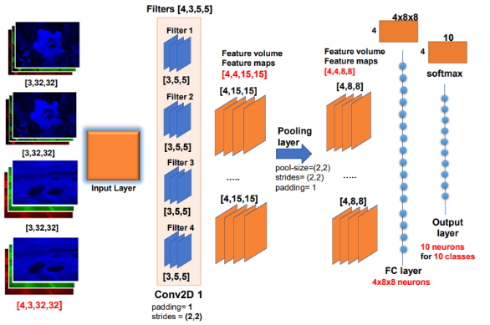
Swin Transformers Shifted Window Self-Attention: allows a token to interact with the ones in the different local windows. enables the interaction across local windows, shifts a local window to right and bottom to become a new local window. output shape of same as the input shape.
ViT capture Global Info of Image cuz: Multi-head Self-attention layers of the Encoder blocks. The global information is captured in the class token at the final layer because this summarizes the token embeddings at the input layer.
We use three weight matrices 𝑊_{𝑄}, 𝑊_{𝐾}, 𝑊_{𝑉} to compute 𝑄, 𝐾, 𝑉 respectively. We rely on 𝑄, 𝐾 to compute the attention scores to store in a matrix 𝐵 that has shape [L, L]. 𝑄, 𝐾 can be considered as two other views of 𝑋. We apply the SoftMax function to the attention scores 𝐵 to gain the attention probabilities 𝐴 that has shape [L, L]. We multiply attention probs 𝐴 and 𝑉 to obtain the new token/word embeddings 𝑍 = 𝐴𝑉.
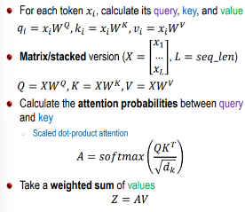
Can compute the token embeddings in parallel. the queries (Q), keys (K), and values (V) computed based on source sequences, can capture intra-sequence dependencies between source sequences
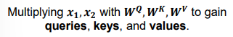
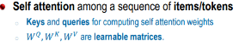
LoRA: insert low-ranked matrices to the key, query, and value matrices of ViTs and then fine-tune these low-ranked matrices
Prompt Tuning: insert learnable prompts to token embeddings of ViTs and then fine-tune these prompts
principle of the model fine-tuning with additional components: fine-tune the additional components only, consider the additional components as variables to optimize in optimizers
Generative Model: Learn to generate meaningful and good examples that imitate realistic examples in a given dataset from noises
Adapters: insert adapters to pointwise networks of ViTs and then fine-tune these adapters
This is our input sentence, we embed each word, Split into 8 heads. We multiply X or R with weight matrices, calculate attention using the resulting Q/K/V matrices, Concatenate the resulting Z matrices, then multiply with weight matrix W⁰ to produce the output of the layer

Cross Attention
Perform self-attention multiple times in parallel and combine results
Multi-head self-attention
Each head has its own 𝑊_{𝑄}, 𝑊_{𝐾}, 𝑊_{𝑉}. We perform each head independently. We concatenate the outputs of each head and input this concatenation to one more linear layer 𝑊𝑜 to gain the output of multi-head Self-Attention.
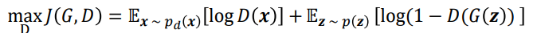
involved in the computation of decoder output. inject the encoder output to the decoder layers. the decoder input is used to compute 𝑄, whereas the encoder output is used to compute 𝐾, 𝑉.
Conv2D Layers: Process 2D and 3D tensors. Provide some filters to detect the patterns inside an input tensor.
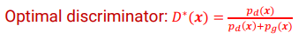
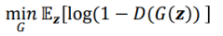
Mode Collapse: The generated data can cover only a few modes in real data and miss many other modes. Cuz cannot solve the min-max problem of GANs perfectly. When updating the generator, there is not any constraints for it to generate data corresponding to all modes
CNN Bad: cannot capture the global information of images, cannot capture the spatial relationship of local objects inside images, locality sensitivity
Batch Norm Layers: Mitigate Overfitting, Training phase use batch statistics, testing phase use population statistics (mean & std).
Pooling Layers: Preserve the crucial information in the input. Reduce the input size to make it more manageable.
Can compute the token embeddings in parallel. the queries (Q) are computed based on target sequences, while keys (K), and values (V) are computed based on source sequences, can capture inter-sequence dependencies between source sequences and target sequences
Fake example and Data Overlap: task of discriminator harder, accuracy approach 50%
GAN: use a discriminator to be aware of the difference or divergence between the distribution of generated examples and the distribution of data. noise is fed to the generator to generate fake examples, generator fool d by generating exp mimic real data. discriminator tries to distinguish/discriminate the real and fake data examples by set high for real and low for fake
or
It is more effective than Batch Norm for sequential data. normalizes the input tensor across the embedding size dimension. It has the scaling and shifting parameters 𝛾 and b, add input back to output, help preserve info
Residual add and layer norm
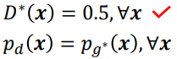
Nash Equilibrium
apply sigmoid at the output layer of discriminator. 𝐷(𝒙) is the probability 𝒙 to be a real example. 1 − 𝐷(𝒙) = fake
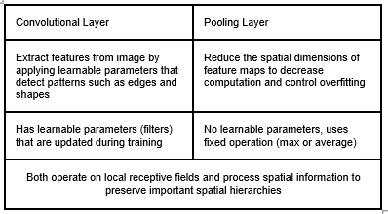
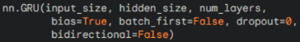
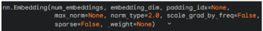
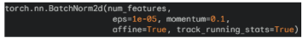
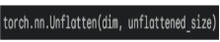
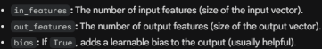
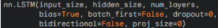
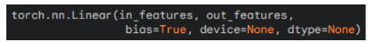
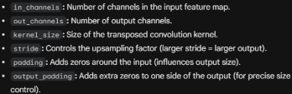
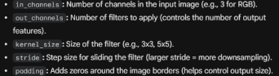
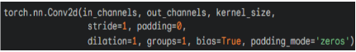
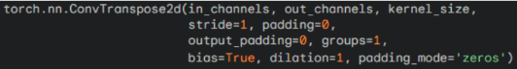
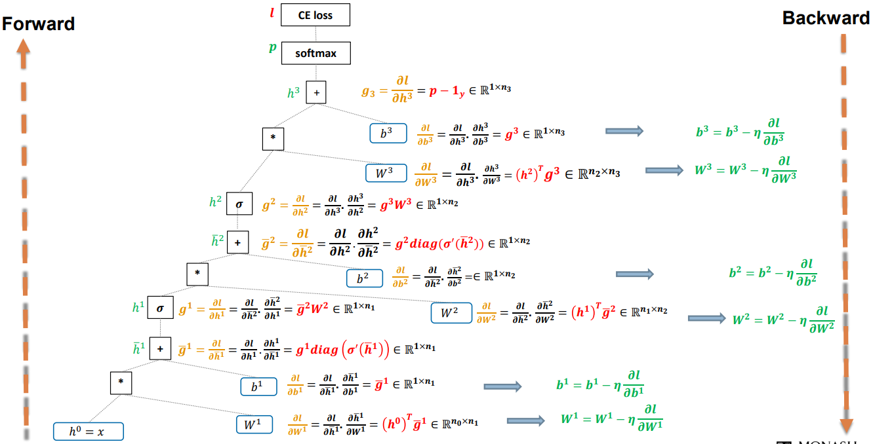
A fundamental RNN that processes sequences by looping through time steps, passing information through a hidden state.
Simpler but struggles with long-term dependencies (no gates)
A simplified version of LSTM, faster and more efficient. Uses update and reset gates to control what information to keep or forget, learning patterns in sequential data.

Flattens (combines) multiple dimensions of a tensor into one so can fit into full connected layer. start_dim: where flattening begins (default = 1, keeps batch size separate) end_dim: where flattening ends (default = -1, flattens until the last dimension).

Performs max pooling, downsampling that reduces spatial size (height & width).
Divides the input into small regions and outputs the maximum value from each region.
Acts as a feature magnifier, keeping the strongest features and reducing noise. kernel_size: size of pooling window, stride: how far the window moves each step (larger stride = more downsampling). padding: adds zeros around the border if needed.
AdaptiveAvgPool2d automatically averages feature maps to reach a specific output size, summarizing spatial information into a compact representation.
nn.Embedding creates a lookup table that maps word indices to dense vector embeddings. mainly used in NLP to convert words or tokens into meaningful vector representations. num_embeddings → Vocabulary size. embedding_dim → Size of each embedding vector. padding_idx → Index for padding tokens that won’t be updated during training.
Applies batch normalization to 2D feature maps. Normalizes each channel’s activations using the batch mean and variance. Stabilizes and speeds up training by reducing internal covariate shift. num_features: number of channels in the input. eps: small constant to prevent division by zero. momentum: controls how running mean/variance are updated. affine: if True, learns scale (γ) and shift (β) parameters. track_running_stats: keeps running averages for inference.
Restores a flattened dimension back into multiple dimensions. dim: which dimension to unflatten. unflattened_size: tuple or list defining the new shape.

nn.LSTM type of RNN that handles sequential data. It captures long-term dependencies using internal memory cells and gates (input, forget, output) to decide what information to keep or discard. input_size: Number of features in input. hidden_size: Size of hidden state. num_layers: Number of stacked LSTM layers. bias: Whether to include bias terms. batch_first: If True, input/output shape is (batch, seq, feature). dropout: Dropout rate for regularization between layers.
nn.Linear is a fully connected layer that connects every neuron from one layer to every neuron in the next. It performs a matrix multiplication of the input with a weight matrix and adds a bias, allowing the model to learn relationships between features.
nn.ConvTranspose2d performs a transposed convolution, which is used to upsample feature maps, increasing their spatial size.
It acts as the reverse of nn.Conv2d, instead of downsampling and extracting features, it reconstructs higher-resolution outputs, commonly used in image generation
nn.Conv2d performs a 2D convolution to extract features from images by sliding filters over them to detect patterns like edges, corners, and textures.
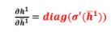
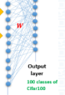
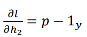
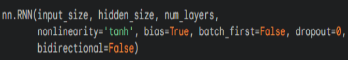
W shape = [no. of neuron, 100], store representation at fc, store logits of image at output. Batch loss = compute cw loss for each row by comparing with ground truth label, then take average to calculate batch loss
input_size – Number of features in each input step. hidden_size – Number of features in the hidden state (memory capacity). num_layers – How many GRU layers are stacked. bias – Whether to use bias terms in the gates (default: True). batch_first – If True, input/output tensors are in shape instead of (seq, batch, feature). dropout – Adds dropout between GRU layers (for regularization).
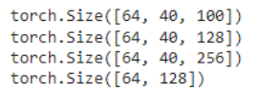
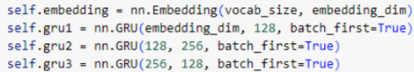
Role of BOS and EOS symbols BOS indicates the start of a sequence so that the model knows when to begin generating or encoding tokens, EOS marks the end of a sequence so that the model knows when to stop generating output or terminate decoding

Common strategies of Inference in seq2seq Greedy Decoding: At each time step, choose the token with the highest probability (formula). Simple and fast but may miss globally optimal sequences; Beam Search: Keeps the top-k (beam width) most probable partial sequences at each step and expands them. Finally, select the sequence with the highest overall probability. Beam search is better because it explores multiple candidate paths, giving a higher chance of finding the globally optimal or more fluent sequences, especially in tasks like translation or captioning. Greedy Decoding is faster but often less accurate.

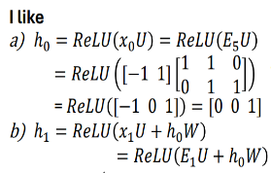
Skip-gram uses the target word to predict the context words in a window. Drawbacks of SkipGram The output layer has N neurons where N is a large vocabulary size. Compute the prediction probabilities p = [p1,....,pN] by applying softmax to the output which is very computationally expensive. The values of p1,...,pN are very tiny which are hard to train

Difference between Data Augmentation and Adversarial Training -Similarity: Both adversarial training and data augmentation expand the training data by adding modified versions of existing samples to improve generalisation and robustness -Differences: DA uses natural transformations (Eg. flipping, rotation); AT uses worst case perturbations (adversarial noise) designed to fool the model, DA improves generalisation to normal data variations; AT improves robustness against malicious or adversarial attacks

The class token contains global image info through self-attention; it becomes a weighted sum of all patch embeddings from previous layers. Since the first layer’s tokens represent the image patches, the class token gradually integrates information from all image regions, capturing the entire image context.

Shape of token: [batch no(count), sequence length(count), embedding size (C-dimensional)] input size = output size

Drawbacks of time-invariant context vector c. In the seq2seq model, the encoder compressed all input information into a single fixed vector c. This causes an information bottleneck where it is hard for c to represent long or complex input sequences, leading to poor performance on long or complex sentences.

Adversarial examples in reality. A CNN-based image classifier used in autonomous vehicles for traffic sign recognition. An attacker can add subtle noise to a stop sign that does not affect human perception but cause CNN to misclassify it as a speed limit sign. The misclassification could cause the vehicle to ignore the stop sign, posing serious safety risks.

How global attention helps in improving seq2seq models Enables the decoder to focus on relevant source words for each output token. Improves translation accuracy, handling of long sentences and interpretability (via attention weights. Reduces the information bottleneck by replacing a single fixed vector with a context that adapts over time

Steps of Negative Sampling Turn multi-class classification into binary classification; Given a pair of (context word, target word), sample some negative words from the vocab; Assign the pair (context word, target word) to label 1 & the pairs (context word, negative word) to label 0; Cast to a binary classification problem

Purpose of Word2Vec Transform symbolic representations of a word into numeric representation (vector) which preserve semantic & syntactic relationship carried in a text corpus

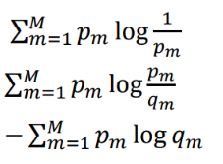
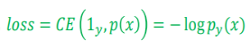
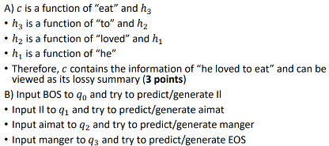
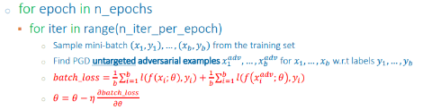
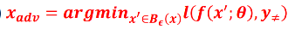
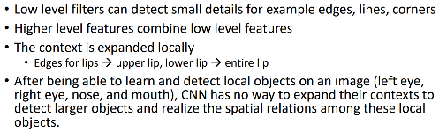
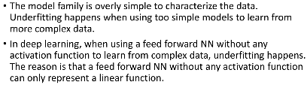
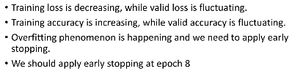
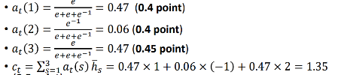
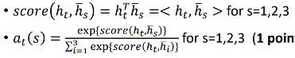
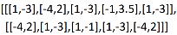
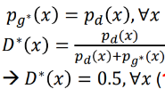
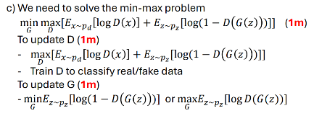
KL Divergence
Entropy
CE Divergence
context vector c summarizes the content because it is computed from the encoder’s hidden states, which sequentially encode all information from the input sequence.
How perform adversarial training for this mini-batch to improve model robustness
𝑥𝑎𝑑𝑣 in the ball around 𝑥 that maximizes the loss function w.r.t. 𝑦
where 𝑦 is the ground-truth label of x
𝑥𝑎𝑑𝑣 in the ball around 𝑥 that minimizes the loss function w.r.t. a
targeted label 𝑦# ≠ 𝑦 where 𝑦 is the ground-truth label of x

Adversarial example. The adversarial example 𝑥𝑎𝑑𝑣 of 𝑥 looks similar to 𝑥 from human perspective, but it can fool the model 𝑓, i.e., the model 𝑓 predicts 𝑥𝑎𝑑𝑣 and 𝑥 with different labels or the model 𝑓 predicts 𝑥𝑎𝑑𝑣 to the label 𝑦𝑎𝑑𝑣 different from the ground-truth label 𝑦 of 𝑥.

GAN. Generator, noise has shape
[1, noise_dim]. This is mapped to [1,7x7x128]. Later, it is unflattened to [1,128,7,7]. This is further inputted toConvTranspose2d to gain [1, 64, 14,14]. Again, it is inputted to ConvTranspose2d to gain [1,1,28,28]. Purpose: fool discriminator by generating fake images that look identical to real images. Discriminator, we start with an image [1,1,28,28]. We applyConv2d to gain [1,64,14,14]. We further
apply Conv2d to gain [1,128,7,7]. We
then flatten to [1,128x7x7]. Finally, we
apply the linear layer with sigmoid activation to
gain [1,1] of the probability to predict an image
to real class. Purpose: classify real and fake images
The generator G* generates fake images that look very similar for real images. The discriminators cannot distinguish real/fake images, hence providing the probabilities 0.5/0.5 to real/fake classes.
Rmb e^ up down

